Part 1. Description of the Algorithm

1. Solution Representation
A route is a permutation of city IDs.
Example:

2. Initial Population
Population is a list of such permutations.
Created using:
- random routes
- optionally greedy routes
Example:
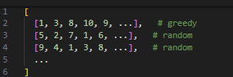
3. Fitness Function
Fitness = total Euclidean distance of the tour.
Lower fitness → better route.
Example:

4. Selection Method
Tournament selection:
pick k random individuals → choose the one with the best (lowest) fitness.
Example:
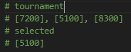
5. Crossover Operator
Ordered Crossover (OX).
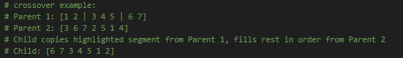
6. Mutation Operator
Inversion mutation — reverse a random subsequence.
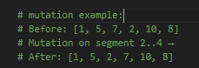
7. Generation Update (Epoch)
For each new individual:
- select parents
- crossover with probability Pc
- mutation with probability Pm
- add to new population
Example:
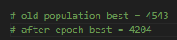

8. Main GA Loop
Repeat several epochs:
- generate new population
- track global best
- record fitness history for plots
Example (berlin11 best fitness per epoch):

Part 2. Parameter Testing and Comparison

2.1 Baseline GA (Default Parameters)
Default used in code:
- Tournament size: Ts = 3
- Crossover probability: Pc = 0.8
- Mutation probability: Pm = 0.3
- Epochs: 150
Baseline chart — Best fitness per epoch (200 epochs here)
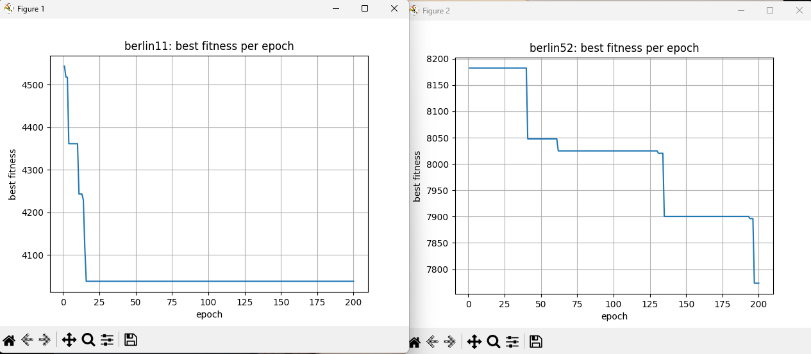
berlin11 (11 cities)
– very fast convergence: best fitness drops in the first ~20 epochs.
– long flat plateau: the GA stops improving early due to low diversity.
– greedy initialization makes the search start close to a good solution.
berlin52 (52 cities)
– slow, step-like improvements: long stagnation periods, occasional drops.
– GA often gets stuck in local minima and escapes only through mutation/crossover.
– improvements continue even near epoch 200, but progress is limited.
comparison
– small instance converges quickly but prematurely.
– larger instance exposes weak exploration in the baseline GA.

2.2 Parameter Experiments
Now we test how changing parameters affects performance.

Experiment Group 1 — Mutation Probability (Pm)
Test values (example):
- Pm = 0.20
- Pm = 0.30 (baseline)
- Pm = 0.35
- Pm = 0.40
Chart: Best fitness per epoch for different Pm
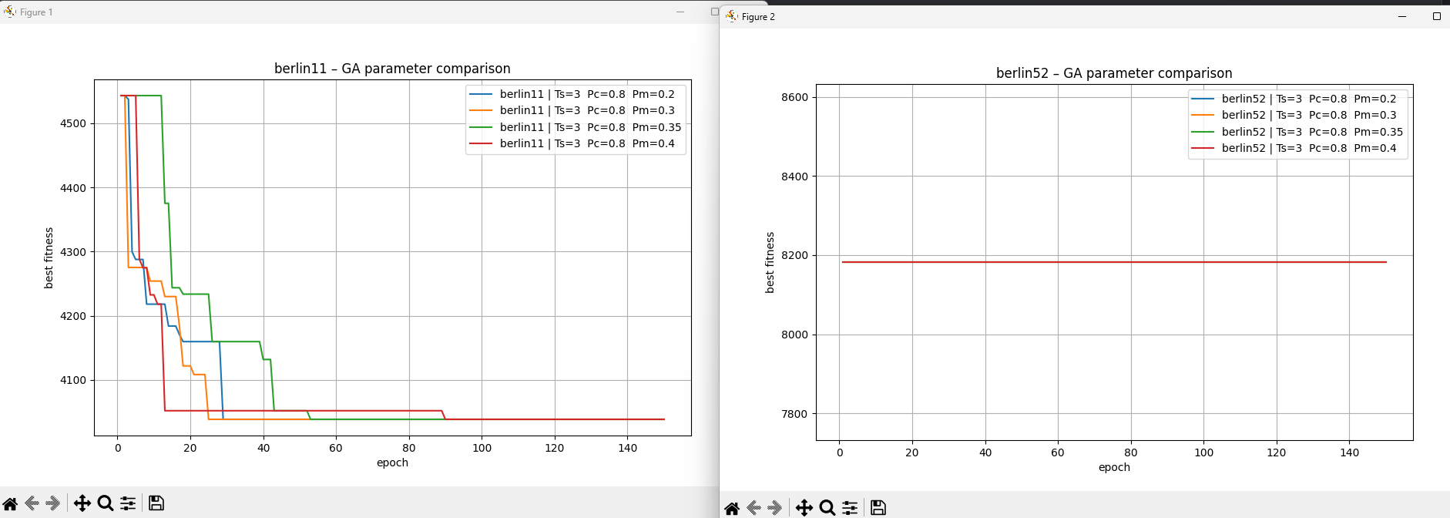
Observations
berlin11 — observation
the GA consistently improves the solution for all mutation values:
- Pm = 0.2–0.3 converge fastest and reach the best final fitness.
- higher mutation (0.35–0.4) slows down convergence and produces noisier trajectories.
- Pm = 0.4 performs the worst, getting stuck above the optimal plateau.
conclusion: moderate mutation (0.2–0.3) is optimal for berlin11; too much mutation destroys good structures.

berlin52 — observation
all lines overlap perfectly — the graph is flat:
- the GA does not improve the initial solution at any mutation level.
- Pm = 0.2–0.4 produce identical behavior: zero progress across all 150 epochs.
- mutation alone is not strong enough to escape the greedy baseline or introduce useful diversity.
conclusion: mutation changes have no effect on berlin52 under this setup. to achieve improvement, the GA needs a larger population, more epochs, stronger selection, or additional diversification mechanisms.

Experiment Group 2 — Crossover Probability (Pc)
Test values:
- Pc = 0.70
- Pc = 0.80 (baseline)
- Pc = 0.90
- Pc = 0.95
Chart: Best fitness per epoch for different Pc
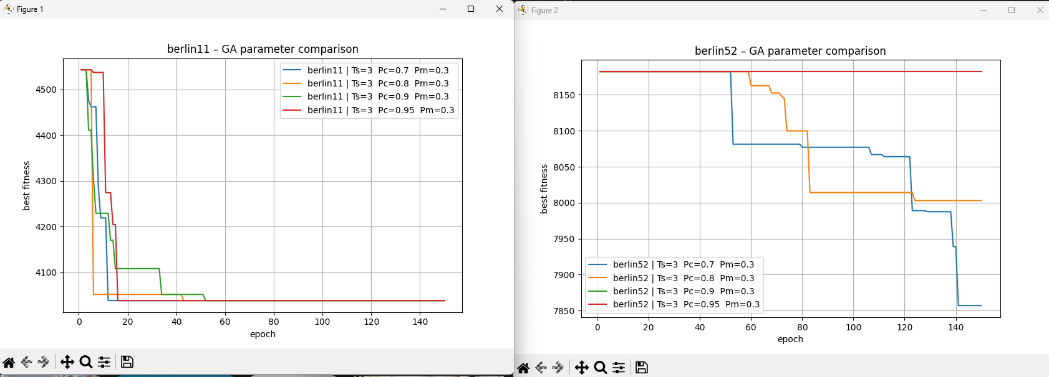
Observations
berlin11 — observation
the GA improves very quickly for all Pc values.
key points:
- Pc = 0.7, 0.8, and 0.9 all converge fast to the same ~4050 region.
- Pc = 0.95 converges the slowest and gets stuck at a worse value — too much crossover disrupts good structures.
- moderate crossover (0.7–0.9) gives the most stable and fastest improvement.
- the differences are small because the instance is easy and the greedy seed is strong.
conclusion: berlin11 works best with medium crossover (0.7–0.9); too high Pc harms stability.

berlin52 — observation
the GA now improves on berlin52 (unlike the previous run), and Pc has a clear effect:
- Pc = 0.7 and Pc = 0.8 show gradual step-like improvements.
- Pc = 0.9 improves slightly but plateaus earlier.
- Pc = 0.95 does not improve at all — the line is flat, indicating complete loss of useful building blocks.
conclusion: for berlin52, lower crossover (0.7–0.8) performs best; very high Pc disrupts good partial routes and prevents long-term improvement.

Experiment Group 3 — Tournament Size (Ts)
Test values:
- Ts = 2
- Ts = 3 (baseline)
- Ts = 5
- Ts = 7

Chart: Best fitness per epoch for different Ts
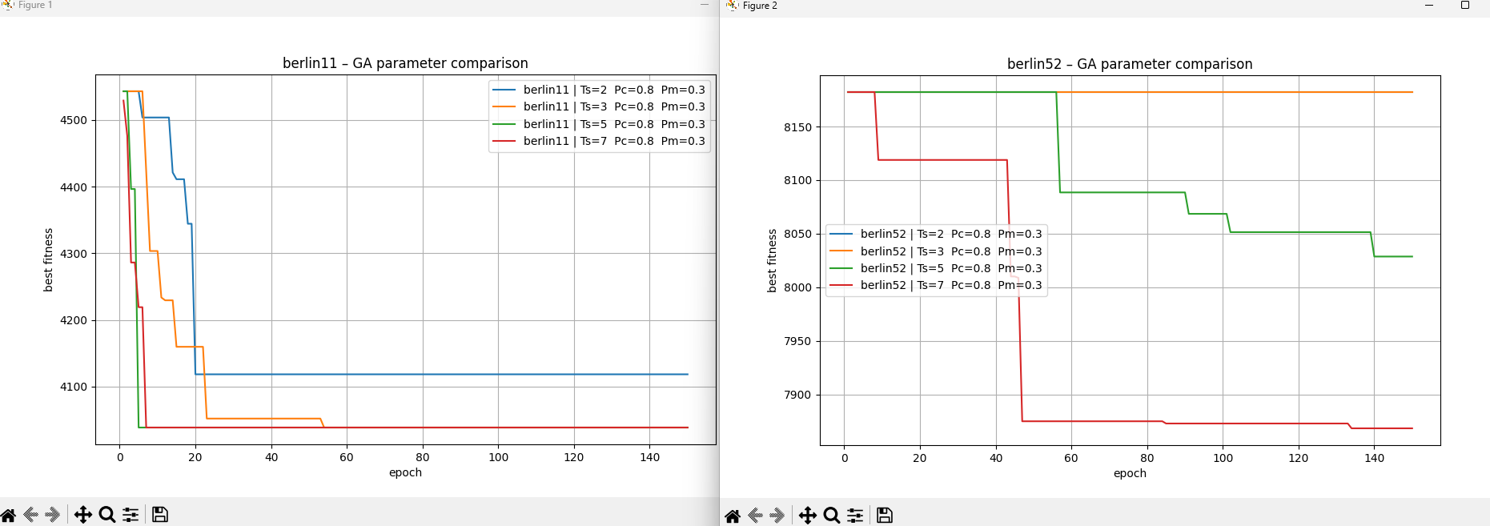
Observations
berlin11 — observation
tournament size has a clear impact:
- Ts = 2 converges slowly and stops at a worse fitness.
- Ts = 3 converges faster and reaches a better final value.
- Ts = 5 and Ts = 7 converge the fastest and reach the best solution (~4050).
- larger Ts increases selection pressure, speeding up convergence and reducing randomness.
conclusion: higher tournament size (5–7) works best for berlin11 — it accelerates convergence and improves final quality.

berlin52 — observation
the effect of Ts is much stronger here:
- Ts = 2 shows minimal improvement.
- Ts = 3 does not improve at all — the line stays flat.
- Ts = 5 improves slowly in step-like drops.
- Ts = 7 gives the best performance, escaping local minima early and achieving the lowest fitness.
conclusion: for berlin52, stronger selection pressure (larger Ts) is crucial. Ts = 7 clearly outperforms the others and is the only setting that consistently escapes poor initial solutions.

2.3 Summary of Best Parameters
For berlin11 (small instance)
- Tournament size: 5–7
- Crossover probability: 0.7–0.9
- Mutation probability: 0.2–0.3
Reason: small instances converge quickly; medium–high selection pressure and moderate mutation give the fastest and most stable improvement.

For berlin52 (larger instance)
- Tournament size: 7 (best by far)
- Crossover probability: around 0.7–0.8
- Mutation probability: 0.2–0.3 (higher values did not help)
Reason: berlin52 requires strong selection pressure to escape local minima. extremely high Pc or Pm disrupts good structures, while Ts=7 provides consistent improvement.

Overall conclusion
- Selection pressure (Ts) has the strongest positive impact, especially on berlin52.
- Moderate crossover (Pc) and moderate mutation (Pm) consistently outperform extreme values.
- For both datasets, stable performance is achieved with:
Ts = 5–7, Pc ≈ 0.7–0.8, Pm ≈ 0.2–0.3.
Part 3 — Comparison of GA, Greedy, and Random Approaches (Berlin52)
This section compares the performance of the Genetic Algorithm (GA) with the best tuned parameters against two baseline methods:
(1) Greedy Nearest Neighbor (all starting cities), and
(2) Random Search (1000 runs).
The comparison includes:
- 10 independent runs of the GA with the best parameter configuration,
- Statistical analysis (mean, standard deviation, variance),
- Best greedy results (top 5),
- Random search best score and statistics.

Genetic Algorithm — 10 Runs (Best Parameters)
Parameters used:
- Tournament size: 7
- Crossover probability: 0.8
- Mutation probability: 0.25
- Population size: 50
- Epochs: 150
Table 1. GA performance across 10 runs
Run | Fitness
1 | 7832.21
2 | 7713.03
3 | 7860.10
4 | 8022.68
5 | 8182.19
6 | 7786.59
7 | 7854.33
8 | 7729.52
9 | 7925.21
10 | 7917.65
Table 2. GA statistics
Metric | Value
Mean | 7882.35
Standard deviation | 140.50
Minimum | 7713.03
Maximum | 8182.19
The GA clearly outperforms both greedy and random search methods, achieving significantly lower route lengths.

Greedy Algorithm — All Starting Cities
52 greedy runs were performed (one from each city).
Below are the best 5 results.
Table 3. Best 5 greedy results
Rank | Fitness
1 | 8182.19
2 | 8207.61
3 | 8848.98
4 | 8866.87
5 | 8866.87
Table 4. Greedy statistics (all 52 runs)
Metric | Value
Mean | 9373.43
Standard deviation | 476.21
Minimum | 8182.19
Maximum | 10,299.37
Greedy performs moderately well and occasionally finds a good solution, but on average is far worse than the GA.

Random Search — 1000 Runs
Random search simply generates 1000 random permutations.
Table 5. Random search results
Metric | Value
Best score | 24,660.76
Mean | 29,915.54
Standard deviation | 1,583.71
Minimum | 24,660.76
Maximum | 34,877.10
Random search performs extremely poorly on TSP, as expected.
Its best result is more than 3× worse than the worst GA result.

Conclusion
The comparison clearly shows:
Method | Typical Result | Notes
Genetic Algorithm | ~7700–8200 | Best performance, stable, lowest average distance
Greedy (best start) | ~8182 | Decent, but worse than GA
Random Search | ~25,000–35,000 | Ineffective for TSP
The Genetic Algorithm with tuned parameters significantly outperforms both baselines, achieving the shortest route lengths and the lowest variance across multiple runs.
Part 4 — Additional TSP Instances (11, 52, 100, 150)

Best GA Results
Instance | Best GA Fitness
Berlin11 | 4038.44
Berlin52 | 7544.37
KroA100 | 22937.13
KroA150 | 31482.02
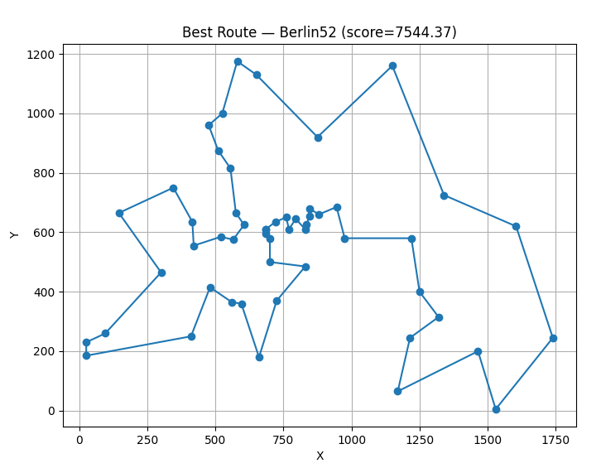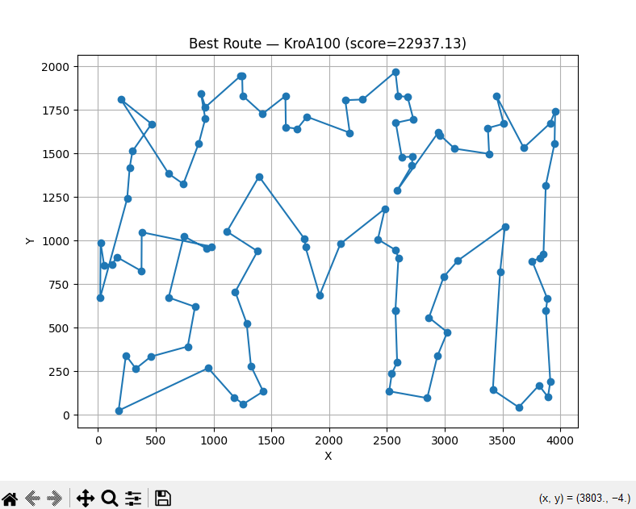
Short Summary
- GA gives the best results on all datasets.
- Greedy works acceptably on small instances, worse on larger ones.
- Random search performs the worst in all cases.

Part 5 — Conclusions
Across all experiments, the Genetic Algorithm demonstrates clear advantages over both greedy and random approaches for solving the Traveling Salesman Problem. The GA effectively balances exploration and exploitation through tournament selection, ordered crossover, and inversion mutation, producing consistently better solutions across all tested instance sizes (11, 52, 100, 150 cities).
Parameter tuning shows that selection pressure (tournament size) has the strongest overall impact on performance, especially for larger datasets. Moderate crossover (0.7–0.8) and moderate mutation (0.2–0.3) yield the most stable and competitive results, while extreme values tend to slow convergence or disrupt useful structures.
Comparative analysis confirms that the GA outperforms greedy search on all but the smallest instance, achieving significantly shorter routes and lower variance. Random search performs the worst and does not provide meaningful solutions for any dataset size.
Visualization of the best routes further illustrates that GA-generated solutions form coherent, efficient tours with fewer unnecessary long edges.
Overall, the GA is the most effective, scalable, and reliable method among those tested. It adapts well to increasing instance complexity and consistently produces high-quality solutions, validating it as a strong method for tackling the TSP.

